MAS8403 Statistic Foundation of Data Science

R Solution

Practical 2: The Poisson process

Note: If any symbol is mess, just maximum the window, then double click the symbols

Question 1:

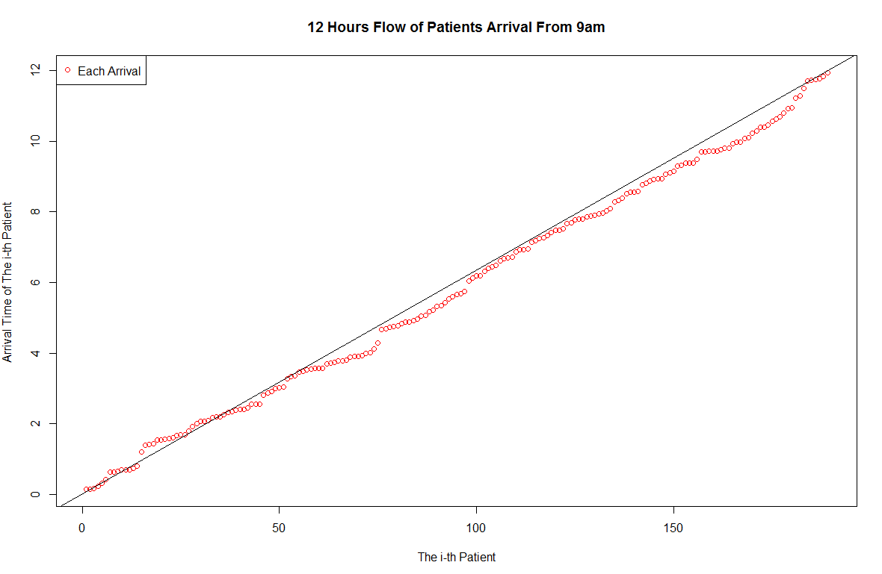

I think this question is compatible with Poisson Process from my Plot.

And if we got the mean for all, if it compatible with Poisson process, mean will equal to variance equal to lambda, so we can see in the plot, it should be compatible to the lambda more or less, so it compatible with Poisson process.

Question 2:

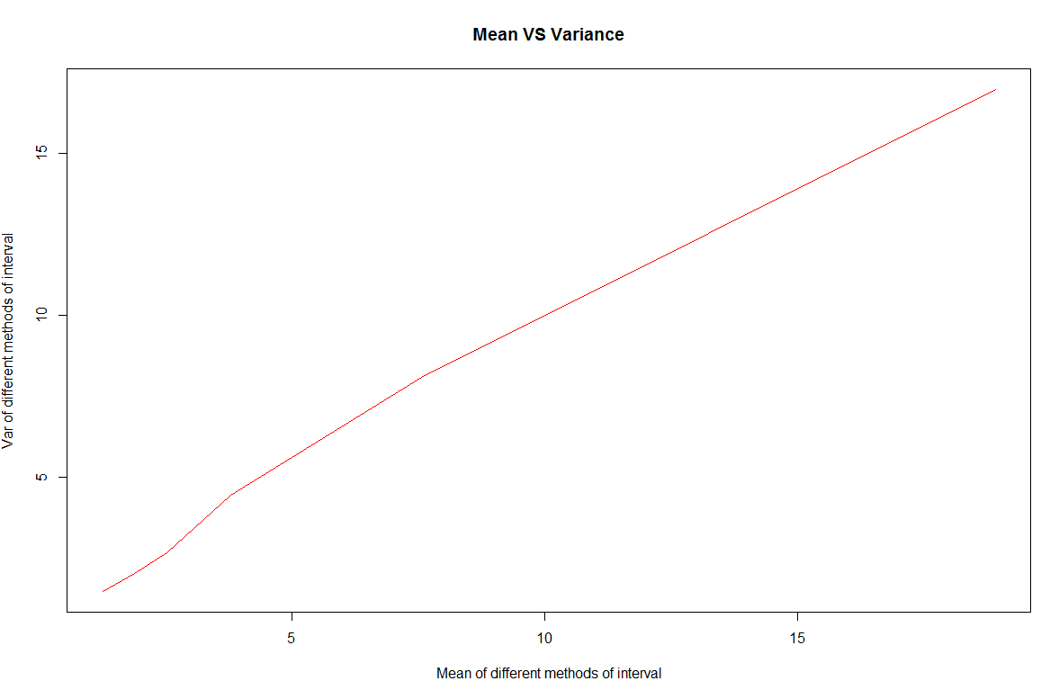

The plot supports the idea the arrivals follow a Poisson process. The λ is the average arrivals in unit time (Per hour). when the k increases linearly, decreasing linearly of the length of intervals, and the mean an variance of the counts should decrease as well. Another reason is that we can see that when k become very big, mean and variance are close enough, which is same as the fact that the mean and variance of Poisson distribution are equal and equal to lambda.

Estimate of the rate parameter Lambda: 15.75

1. #Question 2
2. main_Question2 = function(){
4. url = '../practical2.dat' #The path of my data
5. data_PA_2 = Load_Data(url) #Load the data
6. E_lambda = c() # Store the each lambda
8. interval = c(10,25,50,75,100,150) # Set the different interval
9. interval_mean = c() # Store the mean for each interval method
10. interval_var = c()  # Store the variance for each interval method
11. E_lambda = c() # store the lambda for each interval
12. count = 1 # count the index of vector above
14. **for** (k_I **in** interval){ # Loop of the different ways of interval
16. inte_num = table(cut(data_PA_2, breaks = k_I)) # The orders of data after cutting
18. interval_mean[count] = mean(inte_num) # Mean for each interval method
20. interval_var[count] = var(inte_num) # variance for each interval method
22. count = count + 1 # Index to next element in vector
23. E_lambda[count] = (mean(inte_num) * k_I) / 12 #Get the lambda for each
24. }
25. # Plot the mean versus variance in different ways of interval
26. plot(interval_mean,interval_var,main = '12 Hours Flow of Patients Arrival From 9am', xlab = 'Mean of different methods of interval', ylab = 'Var of different methods of interval',type = 'l', col='red')
27. }
29. main_Question2() # Run the Question2

**Question 3:**

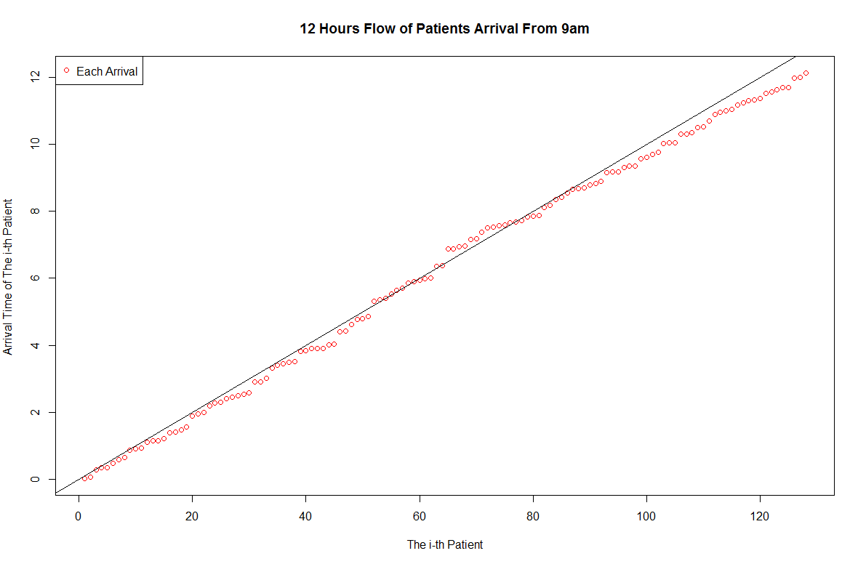

For this question, we know the rate is 10 arrivals per hour, so we can get a line as $y= \frac{1}{10}x$, after we generate the arrivals and their times,, we can see that the distribution on the plot is almost follow the ‘rate is 10 arrivals per hour’(Just lambda, and the expectation, variance must almost equal to lambda 10).

1. #Question 3
2. #lambda :
3. #       choose the lambda in Poisson distribution
4. #
5. Question3 = function(**lambda**){
7. y_store = c() # store the each time generated by rexp
8. t_store = c(1) # store the time of each patient
9. count_times = 1# count the index of vector above
11. **while**(t_store[length(t_store)] <= 12) { # Loop of the Time until it exceeds 12
13. arrivals = rexp(1,**lambda**) # just generated the time follow exp randomly
15. y_store[count_times] = arrivals # store the each time generated by rexp
17. t_store[count_times] = cumsum(y_store)[length(y_store)]
18. #Store the time of each patient's arrival
20. count_times = count_times + 1 # Index to next element in vector
21. }
23. **return** (t_store) # Return the time we stored for each patient
24. }
26. main_Question3 = function(){
28. **lambda** =10
30. arr_times = Question3(10) # Get the arrival time
32. num_Peo = (1:length(arr_times)) # Get the number of the people
34. #Plot the of the time of the patients
35. plot(num_Peo, arr_times ,main = '12 Hours Flow of Patients Arrival From 9am', xlab = 'The i-th Patient', ylab = 'Arrival Time of The i-th Patient ', col='red')
36. abline(a= 0, b = 1/10) # Give the line about lambda to check
37. legend("topleft", c("Each Arrival"),pch = c(1),col=c('red'),bg ="white")
38. }
40. main_Question3() # Run the Question3

Some Explanations:

The arrival patients satisfy with the Poisson distribution:

$$\frac{λ^{k}}{k!}e^{-λ}$$

(1). Firstly, the random event ‘Patients come to hospital’ should be independent. As for this question, this situation, I think it is independent.

(2). Secondly, we can easily think that if we divide the time into many short times. The probability of the event that happens once will increase with the increasing of the length of the short times. (Direct Proportional)

(3). Thirdly, making assumption, each patient is independent, we can easily think that in a very short time just one different patient come. Even there are two patients come, they won’t across the door in the meantime. But if the plot is like ‘ $∩$‘, it does not follow the Poisson Process.

(4). Obviously, we can see the plot is looks like these three inferences.